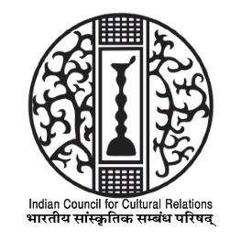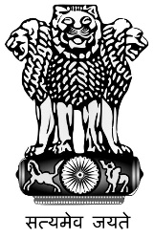
HINDI DIWAS PROGRAMME

12:00 PM Opening of Vishwa Hindi Diwas by Director-ASCC, Inviting Guests

12:05 PM Ambassador of India, Sri Kumar Tuhin Invited to give Welcome Address

12:10 PM President ICCR, Sri Vinay Sahasrabuddhe invited to give keynote speech

12:20 PM Talk on Growth of India Studies & Hindi in Hungary, The Way Forward: Dr. Maria Negyesi ( Former HOD, Dept of India Studies, ELTE Univ)

12:22 PM Hindi Students Poetry Recitation

12:30 PM Hindi & Bollwood Connection in Hungary: A Documentary

12:40 PM Mr. Sanjay Gupta in conversation with Prof. Peter Sagy ( Poet & Hindi Professor , ELTE Univ, Budapest)

12:50 PM Winners of Poetry & Essay Contest announced by Ambassador

12:55 PM Odissi, Sarod & Tabla Fusion Presentation

1:05 PM Vote of Thanks

